Week In Review - May 10-17
Alex Shvartsman
Note: I have not been able to answer Week In Review related e-mails over the last week or so, because of lack of Internet connection (I am moving to the new house). I will do my best to catch up and answer all e-mails next week.

GRAND PRIX YOKOHAMA
Almost 900 people (just under 300 teams) revisited the site of the 1999 World Championship in Yokohama, Japan to compete in the first TGP (Team Grand Prix) of this season. Just a thirty-minute commute from Tokyo, and within a few hours of Osaka via Bullet Train, the numbers were hardly a surprise - those two cities are the major centers of Japan's Magic community.
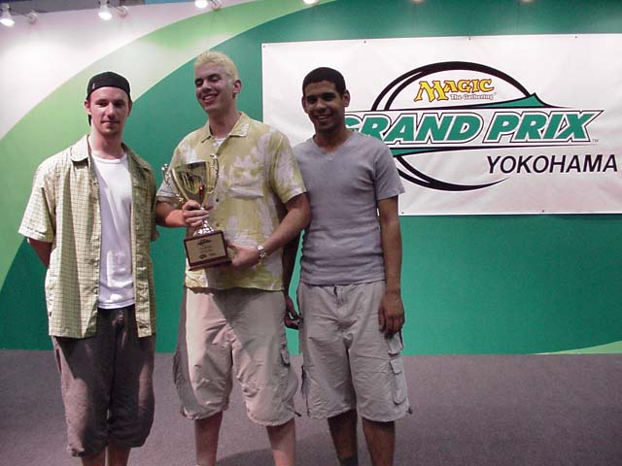
Nice pants: ABU wins in Japan again!
Several international teams have attended the tournament. I played with Mike Pustilnik and Rob Dougherty as team Loafing Giants. This team roster may seem a bit jumbled to you, but it worked out fine - even if we finished out of the money in 14th place. I was going to attend the event anyway. Pustilnik booked his ticket before Pro Tour Barcelona, hoping to use the pro points he might pick up there to maintain his lead in the Player of the Year race. Rob Dougherty was interested in promoting his upcoming strategy web site, which will include a Japanese language page. You will hear more about the site in this column, once it is launched. Our team had an excellent Day 1, losing only to Satoshi Nakamura's team, but we choked on Day 2, going 0-2-1. Was it the lack of practice together or poor luck? Perhaps we'll find out at GP Taipei, where Rob and I will likely play together again, with a third player to be decided.
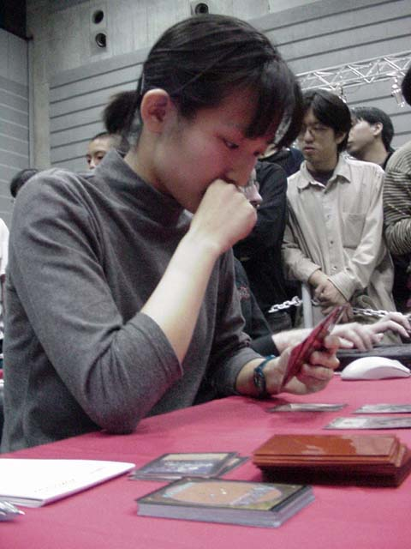
The other notable foreign team was AlphaBetaUnlimited.com. Noah Boeken could not make the trip, so he was substituted for another regular on the Grand Prix circuit - Dave Williams. Williams fit right in with ABU teammates Ryan Fuller and Chris Benafel. They used their practice for Tokyo Masters (which ABU won, after winning the Gateway!) extremely well, running through the tournament with seemingly little effort.
Another notable thing about GP Yokohama was the performance of Otsuka Tomomi. One of several female players to make Day 2 of GP Yokohama, Otsuka Tomomi became a second female GP finalist and a third woman to make the single elimination rounds of a Grand Prix.
For those players not fortunate enough to make Top 20 of the Grand Prix, there was the Tokyo Regional tournament to play in. Japanese Regional tournament differ from most others in two ways. First, they are held over the course of several weekends. Second, the Japanese Nationals slots are awarded based on the region's population and its representation in previous Nationals. This way, the northern island of Sapporo only gets to send Top 4 players from its Regional tournament to Nationals, while Tokyo and Osaka each get to send twenty players. The monster Regional was entered by over 700 players and featured 10 rounds of Swiss play.

NATIONAL CHAMPIONSHIPS
National tournaments are in full swing around the world. The Sideboard has coverage of many major events, which you should check out in order to learn more about the "new Standard" - including Seventh Edition. Notable are nationals in Norway, where Nicolai Herzog won again, this time with a black-red deck, and France, where Pierre Malherbaud won with Fires.

MAGIC TRIVIA
Last week's question:
Urza Planeswalker is one of the key characters in current Magic storyline. What popular TV show featured a minor character named Urza?
Urza was a character in the "Knives" episode of an excellent science fiction series Babylon 5. Boasting a captivating storyline, three-dimensional characters and well-written dialogue, it is in my opinion far superior to any of the Star Trek spinoffs.
New question:
What tournament-playable uncommon card was misprinted with an artwork of a blue rare in Spanish Fourth Edition?
Please do not e-mail me your answers. The correct answer will be posted in next week's column.

BEST OF THE NET
Mindripper offers some treats in form of both winner and finalist reports from the most recent Pro Tours. Check out Kai Budde's two part report: Part 1, Part 2. and the complete report by Alan Comer.

PLAY OF THE WEEK
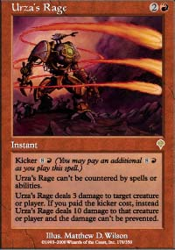
I witnessed the following play in a fun game played by two Japanese competitors at TGP Yokohama. They were playing IBC decks. One was using a black-red "MachineHead" type deck, while the other was playing a Domain variant.
It was relatively late in the game, and both players had a ton of mana available. Domain player used Allied Strategies a turn before to draw five cards and had since then untapped. He was down to three life points. His opponent triumphantly played a twelfth land and cast Urza's Rage with kicker. The Domain player responded by casting Reviving Vapors. He found Spite/Malice, which allowed him to gain eight life - just enough to get out of Rage range. But he did not stop there! He cast another Reviving Vapors, finding Draco to gain 16 more life points! The b-r player counted the burn spells in his graveyard, and packed up his cards.
As always, please send good/bad plays, cool trivia questions, and other news to ashv@concentric.net.

